**Field Work Management.**

**A PROJECT REPORT**

**Submitted By**

**ATUL SINGH**

**University Roll No 1900290149029**

**Submitted in partial fulfillment of the**

**Requirements for the Degree of**

**MASTER OF COMPUTER APPLICATIONS**

**Under the Supervision of**

**Ms.Neelam Rawat**

**Associate Professor**



**Submitted to**

**Department Of Computer Applications**

**KIET Group of Institutions, Ghaziabad**

**Uttar Pradesh-201206**

**CERTIFICATE**

* Certified that **Atul Singh (Roll No. 1900290149029),** have carried out the project work entitled

“**Field work Management**” for the award of Master of Computer Applications from Dr. A.P.J.

Abdul Kalam Technical University (AKTU**)** (formerly UPTU), Technical University, Lucknow under

My supervision. The project report embodies original work, and studies are carried out by the student himself/herself and the contents of the project report do not form the basis for the award of any other degree to the candidate or to anybody else from this or any other University/Institution.

**Date: Atul Singh**

**University Roll No. 1900290149029**

This is to certify that the above statement made by the candidate is correct to the best of my knowledge.

**Ms. Neelam Rawat date:**

Associate Professor

Dept. of Computer Applications.

KIET Group of Institutions, Ghaziabad

**Signature of Internal Examiner Signature of External Examiner**

**Dr. Ajay Kumar Srivastava**

Professor & Head Department of Computer Application KIET Group of Institutions, Ghaziabad

# ABSTRACT

Market research is defined as the process of evaluating the feasibility of a new product or service, through research

conducted directly with potential consumers. This method allows organizations or businesses to discover their target

market, collect and document opinions and make informed decisions.

The process of market research can be done through deploying surveys, interacting

with a group of people also known as sample, conducting interviews and other similar processes.

Primary purpose of conducting market research is to understand or examine the market associated with a particular

product or service, to decide how the audience will react to a product or service. The information obtained from

conducting market research can be used to tailor marketing/ advertising activities or to determine what are the feature

Priorities/service requirement (if any) of consumers.

The purpose of market research is to look at the market associated with a particular good or service to ascertain

how the audience will receive it. This can include information gathering for the purpose of market segmentation

and product differentiation, which can be used to tailor advertising efforts or determine which features are seen as a

priority to the consumer.

A business must engage in a variety of tasks to complete the market research process. It needs to

gather information based on the market sector being examined. The business needs to analyze and interpret the resulting

data to determine the presence of any patterns or relevant data points that it can use in the decision-making process.

Market research helps entrepreneurs make well-informed decisions. It can take the guesswork out of innovation,

and funnel resources into ideas and projects that hold the most potential. Businesses at different stages of growth

carry out market research for different reasons.

**ACKNOWLEDGEMENTS**

Success in life is never attained single handedly. My deepest gratitude goes to my thesis supervisor,

**Ms. Neelam Rawat** for his guidance, help and encouragement throughout my research work.

Their enlightening ideas, comments, and suggestions.

* Words are not enough to express my gratitude to **Dr. Ajay Kumar Shrivastava, Professor and**

**Head, Department of Computer Applications**, for his insightful comments and administrative

help at various occasions.

* Fortunately, I have many understanding friends, who have helped me a lot on many critical conditions.
* Finally, my sincere thanks go to my family members and all those who have directly and

Indirectly provided me moral support and other kind of help. Without their support, completion of

this work would not have been possible in time. They keep my life filled with enjoyment and

Happiness.

**Atul Singh**

# Table of Contents

#### S.No CONTENTS PAGE NO.

Title Page i

Company Certificate ii

Candidate’s Declaration iii

Acknowledgement iv

Abstract Information v

1. Company Profile 1
2. Introduction 2
3. Identification of Need 3-4
4. Objective and Scope of Project 5-6
5. Problem Statement 7
6. System Analysis 8-13
   * Preliminary investigation
   * Feasibility study
7. Software Requirement Specification 13-32
   * Introduction
   * Overall Description
   * Requirement Analysis and Planning Steps GANTT Chart

 PERT Chart

* + System Feature
  + External Interface Requirement
  + Software Quality Attribute
  + Other Non-Functional Requirements
  + Other Requirements

1. Software Engineering Paradigm Applied 33-35
   * Waterfall Model
   * Prototyping Model
2. High Level Design 36-40
   * DFD
   * ERD
   * Use Case Diagram
3. Database Design 41-47
4. Screen Shots 48-71
5. Market Research-Quality Analysis & it’s Types. 72-73
6. Test Cases 73-75
7. Conclusion 76
8. Future Scope 76-77
9. Bibliography 77

## Company Profile

### About the Organization

NSMX (NS Matrix Services Pvt. Ltd.) is a New Delhi based growing company and was founded in year 2011. We are a technology driven company and provide IT Enable services to our dedicated US based market research client. What makes NSMX unique is our ability to help clients meet challenges. We help them enhancing productivity by ensuring the smooth work of business functions economically. And, our ability to conceptualize, architect and implement new and expanded proficiencies which allows our clients to transform legacy models to take their business to the next level.

### Company Mission:

NSMX delivers measurable impact on your bottom line through the use of our services. The primary goal of NSMX is to reduce your cost of development through an effective outsourcing program, thereby allowing you to manage costs as you scale your operations.

We align our services to the short-term and long-term goals of our customers, by giving them a flexible pathway to ownership of the outsourced assets, and development of Intellectual Property.

(HTML, JavaScript, Jscript, ASP, JAVA, SQL and AJAX)

We have the technology experts who can build complex & customized surveys/products to any extend for our clients, Online Serve invests in the latest packages and training to ensure that you always have the best tools and resources available for your project needs.

## INTRODUCTION

The Online Marketing Research is the IT Enable service. The complete title is “Marketing Research (Quality Assurance)”. It can be define as "Market research is the process of collecting valuable information to help you find out if there is a market for your proposed product or service. The information gathered from market research helps budding entrepreneurs make wise and profitable business decisions."

There are two various mode of the marketing research that is the online & offline survey. An Online survey is a questionnaire that the target audience can complete over the Internet. Online surveys are usually created as Web forms with a database to store the answers and statistical software to provide analytics.

The key to any successful business is to understand what it is that your customers want and giving this to them in away that is profitable for you. Many entrepreneurs make them is take early on of thinking that they know what their customers want without ever asking them. This can result in some very expensive mistakes later on.

Online surveys area fast, flexible and affordable route into conducting international market research. Our market research methodologists have a deep understanding of the impact questionnaire design has on completion rates, data quality and respondent positive experience. At NSMX, we design, program host varied online research study range of recognized online survey tools. We offer custom branding, and can handle complex question and routing logic as well as interactive questions, images, audio and visual elements.

## Identification of Need

##### Problem with the Current (Existing) System:

In the existing system all the work is done manually .This is chance of committing errors and it will take more time to perform any transaction. There are so many limitations in the existing system. So the existing system should be atomized. If the system is carried over manually, for every transaction it take more time. So it is difficult to take immediate decisions. It is difficult to find out where the problem is occurring.

Disadvantages of the Existing System:

* Existing system was not user friendly.
* System was not well organized and precise.
* It was time consuming.
* Information was redundant and inconsistent.
* It didn’t integrate all the modules.
* Decision making was difficult.

***Need For Automation:***

* To overcome the limitations of the existing system that will provide the user the facility of choosing the office of protector and apply online for clearing process and save a lot of time, money and physical strength for both Online Survey and Marketing Research department and emigrant.
* Online Survey Marketing Research System will be user friendly.
* It will maintain the information of the emigrants who are registered and who is the protector of emigrant.
* It will also maintain information about the documents required and it automates the process of verifying the emigrants and issuing of clearance certificate.
* At the end of the verification process and after emigrant is verified, an online survey certificate is generated by the POE which is available for the emigrant to download by simply login into their account.

### Automated Processes:

Automated process is a process which is executed automatically by the system. After completion of interaction with the user, the system will perform some automated processes.

* In the user registration process, user is asked to fill a registration form. After filling the form his registration will be completed by the system with the issuing of a user id and password.
* After verification of emigrant protector can generate a certificate automatically.

### Non-Automated Processes:

Non-automated Process is a process, which is completely executed by the human actor. If any modifications are required to the System then the human actor will handle them.

* Document Verification is to be done manually
* Protectors cannot be registered online
* Sending user id and password to the Protectors

## Objective and Scope of Project

### Objective:

* + Online Marketing Research is systematic problem analysis, model building and fact finding for the purpose of important decision making and control in the marketing of goods and services.
  + Marketing Research is a well-planned, systematic process which implies that it needs planning at all the stages. It uses scientific method. It is an objective process as it attempts to provide accurate authentic information. Marketing Research is sometimes defined as the application of scientific method in the solution of marketing problems.
  + Online Marketing Research is a well-planned, systematic process which implies that it needs planning at all the stages. It uses scientific method. It is an objective process as it attempts to provide accurate authentic information.MarketingResearchissometimesdefinedastheapplicationof scientific method in the solution of marketing problems.
  + Online Marketing Research is essential for strategic market planning and decision making. It helps a firm in identifying what are the market opportunities and constraints.

### Scope and limitations:

* + Marketing Research (MR) is not an exact science though it uses the techniques of science. Thus, the results and conclusions drawn upon by using MR are not very accurate.
  + The results of MR are very vague as MR is carried out on consumers, suppliers, intermediaries, etc. who are humans. Humans have a tendency to behave artificially when they know that they are being observed. Thus, the consumers and respondents upon whom here search is carried behave

Artificially when they are aware that their attitudes, beliefs, views, etc. are being observed.

* + MR is not a complete solution to any marketing issue as there are many dominant variables between research conclusions and market response.
  + MR is not free from bias. The research conclusions cannot be verified. The reproduction of the same project on the same class of respondents give different research results.
  + Many business executives and researchers have ambiguity about the research problem and its objectives. They have limited experience of the notion of the decision-making process. This leads to carelessness in research and researchers are not able to do anything real.
  + Huge cost is involved in MR as collection and processing of data can be costly. Many firms do not have the proficiency to carry wide surveys for collecting primary data, and might not also able to hire specialized market experts and research agencies to collect primary data. Thus, in that case, they go for obtaining secondary data that is cheaper too obtain.
  + MR is conducted in open marketplace where numerous variables act on research settings.

## Problem Statement

There are some problems arise with the Existing System:

In the existing system all the work is done manually. This is chance of committing errors and it will take more time to perform any transaction. There are so many limitations in the existing system. So the existing system should be atomized. If the system is carried over manually, for every transaction it take more time. So it is difficult to take immediate decisions.

There are some problems arise with the Existing System:

* Existing system was not user friendly
* System was not well organized and precise
* It was time consuming
* Information was redundant and in consistent
* It didn’t integrate all the modules.
* It is difficult to find out where the problem is occurring
* Registration form are to be filled manually
* Sending user id and password to the Tools

## System Analysis

System is created to solve problems. One can think of the systems approach an organized way of dealing with a problem. In this dynamic world, the subject system analysis and design, mainly deals with the software development activities.

Since a new system is to be developed, the one most important phases of software development life cycle is system requirement gathering and analysis. Analysis involves detailed study of the current system, leading to specification of a new system. Analysis is a detailed study of various operations performed by a system and their relationship within and outside the system. Using the following steps it becomes easy to draw the exact boundary of the new system under consideration.

Keeping in view the problems and new requirements, work out the pros and cons including new area of the system.

All procedures, requirements must be analyzed and documented in the form of detailed DFDs, logical data structure and miniature specifications.

#### System Analysis is conducted with the following steps

* Information gathering
* The tools of structured analysis
* Identification of Need
* System Planning and initial investigation
* Feasibility study
  + ***Information Gathering:***
* Information about the firm
* Information about the work flow
* Various tools used are:

### The tools of structured analysis:

* DFD
* Data Dictionary
* Decision Tree and Structured English

### Initial investigation:

* Problem definition and project initiation
* Determining the requirements
* Needs identification
* Dimension of planning
* Determination of feasibility

### Feasibility Analysis:

* System Performance definition
* Identification of system objectives
* Description of outputs

#### 

* Evaluation of project request is major purpose of preliminary investigation.
* It is the collecting information that helps committee members to evaluate merits of the project request and make judgment about the feasibility of the proposed

Projects.

* To answer the above questions, system analysts discuss with different category of person to collect facts about their business and their operations.
* When the request is made, the first activity the preliminary investigation begins.
* Preliminary investigation has three parts-

1. Request clarification
2. Feasibility study
3. Request approval

#### Request Clarification:

An information system is intended to meet needs of an organization. Thus the first step is in this phase is to specify these needs and requirements.

* The next step is to determine the requirements met by the system. Many requests from employees and users in the organizations are not clearly defined. Therefore, it become necessary that project request must examine and clarified properly before considering system investigation.
* Information related to different needs of the System can be obtained by different users of the system. This can be done by reviewing different organization’s documents such as current method of storing sales data, complaint data etc. By observing the onsite activities the analyst can get close information related to real system.

#### Feasibility Study:

The feasibility report of the project holds the advantages and flexibility of the project. This is divided into three sections:

###### Economic Feasibility

* **Technical Feasibility**
* **Operational Feasibility**

1. ***Economic Feasibility:***

A systems financial benefit must exceed the cost of developing that system. i.e. a new system being developed should be a good investment for the organization.

The proposed system is economically feasible because:

* 1. The system requires very less time factors.
  2. The System reduces paper cost.
  3. The system will provide fast and efficient automated environment instead of slow and error prone manual system, thus reducing both time and man power spent in running the system.

1. The system will have GUI interface and very less user-training is required to learn it
2. The system will provide service to view various information for proper managerial decision making.

### Technical Feasibility:

Technical feasibility centres around the existing computer system (hardware and software) whether it can support the addition of proposed system, if not, to what extent it can support and the organization’s capacity to acquire additional components.

Our proposed system is technically feasible because –

* + The hardware and software required are easy to install and handle
  + The necessary hardware configuration and software platform is already there.
  + The system supports interactivity with the user through GUI.

Proposed system is technically feasible because of the following reasons:-

1. It’s required less system resources.
2. Expandability will be maintained in the new system. New modules can be added later on the application, if required in the future.
3. The application will have User-friendly Forms and Screens, all validation checks.

### Behavioural Feasibility:

Behavioural feasibility determines how much effort will go in the proposed information system, and in educating and training the users on the new system, along with the new ways of conducting the business. Behavioural study strives on ensuring that the equilibrium of the organization and status in the organization neither are nor disturb and changes are readily accepted by the users.

The proposed system is behavioural feasible because of the following:

The users will accept it because they are already acquainted with computers.

This system is also meant for the general user. Nowadays the Internet is almost familiar to everyone. So, it is not difficult for the user to use the system, in fact they feel comfortable in using this system.

Most of the users are familiar with the web browser and the process of booking the auditorium will be simplified for the users. The organization is definitely ready to welcome the computerized system.

## 7. Software Requirement Specification

### Introduction:

In the present system, Web Application system will be an Online Survey & Marketing Research for individuals, organizations and business owners. Whether you need to understand the factors that shape faculty satisfaction or feedback from students on a new course offering, an online survey can reveal data that will improve programs, processes.

Benefits of the Online Survey & Marketing Research includes a faster, cheaper, more accurate ways of collecting information from a large audience, quick to analyze results of surveys at any time, easy to use for participants and researchers also. Functionalities offered by the Online Survey & Marketing Research include creation of surveys (which include ability to add, delete and modify surveys).

Utilizing our online survey Application you will be able to collect all of your survey based data and generate powerful real time reports based upon your own specifications while at the same time providing a visualization structure for any and all presentations that you may need to make. Our Web Application is an online application that gives you the power and the freedom to do all of the required research that your organization needs in order to generate feedback from your customers, employees, and partners. **Purpose:**

Marketing Research is a well-planned, systematic process which implies that it needs planning at all the stages. It uses scientific method. It is an objective process as it attempts to provide accurate authentic information .Marketing Research is sometimes defined as the application of scientific method in the solution of marketing problems.

Marketing Research includes various important principles for generating information which is useful to managers. These principles relate to the timeliness and importance of data, the significance of defining objectives cautiously and clearly, and the need to avoid conducting research to support decisions already made.

* + The purpose of this document is to write down formally the requirements considered to be necessary for building the Online Marketing Research.
  + The first section provides a brief idea about the working of the project along acronyms, definitions, abbreviations, and reference materials.
  + Section2 provides overview of the system, and a brief description of all the system functions.
  + Section 3 gives a detailed description of the components.

### Intended Audience and Reading Suggestions:

This SRS would be used by the following people-

**Developers:** The developers would use this document to implement the functionalities and to ensure traceability of the software.

**Testers:** The testers would use this document to know the interfaces and to test the software accordingly.

**Users or client:** The users would use this document to verify if the requirements specified satisfy their needs.

### Scope:

Market research covers the following items of study.

1. Size of the present and potential market.
2. Consumer needs wants, habits and behaviour.
3. Dealer wants and preferences.
4. Analysis of the market size according to age, sex, income, profession, standard of living etc.
5. Geographic location of customers.
6. Analysis of market demand.
7. Knowledge of competitors and their products.
8. Knowing the profitability of different markets.

### Existing System with Limitations:

The results of MR are very vague as MR is carried out on consumers, suppliers, intermediaries, etc. who are humans. Humans have a tendency to behave artificially when they know that he yare being observed.Thus,the consumers and respondents upon whom the research is carried behave artificially when they are aware that their attitudes, beliefs, views, etc are being observed.

### References:

* + Google search engine(www.google.com)
  + <http://php.nsmx-creative.com/nsmx_web/>
  + [http://www.managementstudyguide.com/limitations-marketing- research.html](http://www.managementstudyguide.com/limitations-marketing-research.html)
  + <http://www.yourarticlelibrary.com/marketing/marketing-research>
  + [http://www.nsmatrix.com](http://www.nsmatrix.com/)

## Overall Description:

### Product Perspective:

* + The organization would like to implement an online marketing research to automate the current system.
  + Planning to watch company’s strengths with market opportunities by outlining objectives for product and market development and devising strategies and tactics to achieve them.
  + Monitoring the progress of strategy implementation.
  + Watching out continuously for threats to the achievement of those plans.
  + Clark and Clark define marketing research as “The careful and objective study of product design, markets and such transfer activities as physical distribution, warehousing advertising and sales management.

### Product Feature:

The main modules of the project are:

###### Project Manager and Client Requirement

1. **Survey Programming and Scripting**
2. **Testing and Quality Assurance**
3. **Sampling and Monitoring**
4. **DATA Processing & Open ended Coding.**
5. **Tabulation, Charting &Reports**

Detailed descriptions of modules are:

1. **Project Manager and Client Requirement:**

The project manager of the basically deals with the client requirement and the Team management. In this module weal’s provide the timeline of the project and how much time is needed to complete the project. The sub modules areas:

* + Biding of the project and target.
  + Client requirement & Questionnaire Management.
  + Unique Study Id Management.
  + Team Assignment for the project.
  + Management of Time Line of the project.

#### Survey Programming and Scripting:

Our market research methodologists have a deep understanding of the impact questionnaire design has on completion rates, data quality and respondent positive experience. At NSMX, we design program and host varied on line research studies using a range of recognized online survey tools. We offer custom branding, and can handle complex question and routing logic as well as interactive questions, images, audio and visual elements.

* + Clarification on the Client Questionnaire.
  + Adding the study in MIS System.
  + Create Setup of the study.
  + Check and validation Control Management.
  + Quota management.
  + Multiple choice, scales, matrix, ranking, open, closed.
  + Complex skip, piping and branching.
  + Hidden Question and variable management.
  + Multi Language Surveys.
  + Drag & drop interfaces for rating scales.

### Testing and Quality Assurance:

Quality is top of mind at NSMX before data collection even starts. As the pioneer & expert of online research, we’re dedicated to the continuous quality amelioration via various process evolution and technological developments. Quality testing (employing quality, logic and plausibility checks) is an integral, ongoing constituent of all the projects until those are delivered successfully. For instance, all survey links programmed in-house or by third party vendors are tested based on test cases prepared for a particular survey. Fraudulent survey takers and bad data from samples is eliminated using quality control measures. The same follows for other sub processes as well. Our Quality Assurance team also performs multi-platform and cross device

Testing to ensure appropriate survey behavior, data gathering and optimal respondent experience. You only get reliable, decision-ready results that you can count on. It includes the following sub modules:

* + Testing of the Live & Dummy Links.
  + Language testing for Multicounty Project.
  + Logical Testing of the study.
  + Textual Testing.
  + Look and feel Testing.
  + Respondent Data Testing by Random Data Generator
  + Quota full and Terminates testing.
  + Screener testing.
  + Managing Error Log.

### Sampling and Monitoring:

Sampling is the bedrock of market research, we used to pull the respondents those are registered on our database with the required targeting of the survey. And then we used to send sample as per the current update and targeting. Where a set of respondents from a statistical population is selected to represent a specific market, audience, political base or customer base and data collection process is administered and executed to make gathered data ready for analysis. When working with NSMX, a client can rest assure that all areas of concentration are being covered when it comes to giving them the best representative sample available. Respondent used to take the survey and thus on the basis of their status (complete/screen out) they credited few MP(Market Point).We’ve proven expertise in all methods of qualitative, quantitative and other types of research field management. The sub modules of this project is

* + Reserve the Sample for respondent.
  + Targeting audiences for the survey.
  + Sending sample and Link setup.
  + Quota re-check and vendor setup.
  + Monitoring and closing of the study.

### DATA Processing & Open ended Coding:

In online Marketing Research NSMX offers exhaustive internal data processing, cleaning, analysis and open-end coding services. Data preparation includes thoroughly checking the data and inspecting each questionnaire or observation form. Verification ensures that the data from the original questionnaires have been accurately transcribed and meaningful information has been collected. We are able to accommodate imported data from nearly any source (ASCII, Binary, SPSS, Excel, Dimensions). Our centralized data refinement allows us to immaculate, validate and export the sample data for excellent reporting that will allow clients to identify emerging trends.

We know the qualitative aspect of the research. Through Open ended coding services NSMX enable market research organizations to effectively analysis and comprehend customer responses and draw rich and actionable insights. We leverage a proprietary suite of unique Artificial Intelligence tools to derive and analysis explicit as well as latent information within open-ended customer responses. We have extensive experience in preparing listings, code frames, verbatim typing, verbatim coding, and open-end programming of ad-test, product test, and CAPI / CATI studies. Utmost care is taken to create subheadings of the code frame so tables generated has decisive data.

### Tabulation, Charting &Reports:

We know that presenting data in meaningful ways is essential for you in making timely, critical business decisions. Instead of throwing complex deliverables or dense unrefined information at our clients, we’re oriented towards usefulness and simplicity. Our advanced research tools allow us to provide key insights in a highly visual and easy to understand format. Our highly trained, experienced and flexible team generates tables that turn your data into actionable insights. Our interactive reports on survey data will help your team grasp the significance of your findings.

## User Class and Characteristics:

***User classes of the system are as following:***

1. **Client/Company:** The client is the main component of the Project and they are the responsible for following-
   * Set the objective for their Product/services to take Survey.
   * Create a set of Questions and questionnaire.
   * Set the target Audience like Specific region/age/Gender/Countrypersons.
   * Bid the Project for selected Panel Companies.
   * Send the Project Changes
   * Increase or decrease the Quota.
   * View the Final Report.
   * Set the timeline for the project.
2. **Super Client:** SuperClient is responsible for following activities-
   * Accept the bidding proposal.
   * Set the timeline for the project & assign a PM for the Study.
   * Create Study Details in the MIS System.
   * Send the study to Team NSMX.
   * Communication between the Client and Team NSMX.
   * Confirm the Changes Of the Study.
   * Monitoring and Testing of the Study.
   * Launching and closing the study.
   * Can View the Random Generated DATA.
   * Can view the Final Report.

1. **Team NSMX:** NSMX team is responsible for following activities:
   * Receive the Study Request.
   * Send the Clarification and Changes request to client.
   * Script the Study.
   * Generate the test Link and test.
   * Generate the RDG Data.
   * Create the report.
   * Send the sample to the Respondent according to Audience.
   * Launch, Monitor, Close the Study.
   * Data processing and reporting.
   * Send the Report to client.

## Operating Environment:

* + The system developed in Python XML JavaScript HTML5 as front end and SQL as Backend.
  + Minimum hardware and Operating system is required and should be Windows family. And the Survey can also run in the Mobile (Android, Windows Phone, iOS) Tablets.

## Design Implementation and Constraints:

* + Login and password is used for identification of registered users On Client Panel and there is no facility for back button and Link share by other user.
  + This system works only in http and https protocol.
  + Client Panel is only in English and many other languages.

## User Documentation:

A user document should be provided related to the survey in Info Part of the Survey-

1. Set of instruction for the survey
2. About the survey.
3. Approx. Time taken by the Survey.

## Requirement Analysis and Planning Steps:

### GANTT Chart:

A standard technique employed in recent times to keep track of a project's progress is the Gantt chart named after the industrial engineer Henry Gantt (1861-1919). They are easy to draw, easy to understand and readily adaptable to other planning approaches (e.g. Pert Charts).

Each task displayed in the GANTT chart is listed below:

* 1. ***Identify needs and benefits*** Identification of Need and Project Constraints Meet with customers

Establish Product Statement ***Milestone****:* Product Statement defined ***Preparing Feasibility Study***

***Milestone****:* Feasibility Study Completed

### Preparing Software & Hardware Requirement Study

Define Software Scope Information Description Functional Description Behavioral Description Validation Criteria

Hardware Requirement Study

***Milestone***: SRS Complete

### Define desired output/control/input(OCI)

Define Keyboard functions Define modes of interaction.

Define import functions Review OCI with customer ***Milestone***: OCI define

### Isolate software elements

***Milestone***: Software elements defined ***Research availability of existing software*** Research text editing components Research image editing components

Research MS Word document migration components

***Milestone:*** Reusable components identified

### Database preparation

***Milestone***: Database preparation complete

### Coding

***Milestone***: Coding completes

|  |  |  |  |  |  |  |  |  |  |  |  |  |  |  |  |  |  |  |
| --- | --- | --- | --- | --- | --- | --- | --- | --- | --- | --- | --- | --- | --- | --- | --- | --- | --- | --- |
| * 1. ***Implementation of System Security Measures***   ***Mileston*e**: System Security Measures implemented   * 1. ***Testing Software***   **Milestone:** Testing Software Complete  Tabular description of Gantt chart is given below | | | | | | | | | | | | | | | | | |  |
|  | Task Name | Start | Finish | Days | Jan | | Feb | | | March | | | April | | | May | |  |
| **15/**  **1** | **25/**  **1** | **4/2** | **14/**  **2** | **24/**  **2** | **6/**  **3** | **16/**  **3** | **26/**  **3** | **5/**  **4** | **15/**  **4** | **25/**  **4** | **5/**  **5** | **15/**  **5** |  |
| Project  Definition | **15/1/20**  **15** | **17/1/20**  **15** | 3 |  | | | | | | | | | | | | |  |
| System Overview and  Analysis | **18/1/20**  **15** | **23/1/20**  **15** | 6 |  | | | | | | | | | | | | |  |
| Requireme nt Gathering and Software Requireme nt Specificati  on (SRS) | **24/1/20**  **15** | **6/2/201**  **5** | 14 |  | | | | | | | | | | | | |  |
| Tools and Technolog  y | **7/2/201**  **5** | **11/2/20**  **15** | 5 |  | | | | | | | | | | | | |  |
| DataFlow  Diagrams | **12/2/20**  **15** | **21/2/20**  **15** | 10 |  | | | | | | | | | | | | |  |
| Designing | **22/2/20**  **15** | **13/3/20**  **15** | 20 |  | | | | | | | | | | | | |  |
| Coding | **14/3/20**  **15** | **24/4/20**  **15** | 42 |  | | | | | | | | | | | | |  |
| Rework | **25/4/20**  **15** | **29/4/20**  **15** | 5 |  | | | | | | | | | | | | |  |
| Final  Report | **30/4/20**  **15** | **6/5/201**  **5** | 6 |  | | | | | | | | | | | | |  |
| :  **Marketing Research(Quality Assurance)**  24 | | | | | | | | | | | | | | | | | |  |

### PERT Chart:

A PERT chart is a project management tool used to schedule, organize, and coordinate tasks within a project. PERT (stands for Program Evaluation Review Technique), a methodology developed by the U.S. Navy in the 1950s to manage thePolarissubmarinemissileprogram.APERTchartpresentsagraphicillustration of a project as a network diagram consisting of numbered nodes (either circles or rectangles) representing events, or milestones in the project linked by labelled vectors (directional lines) representing tasks in the project. The direction of the arrows on the lines indicates the sequence of tasks.

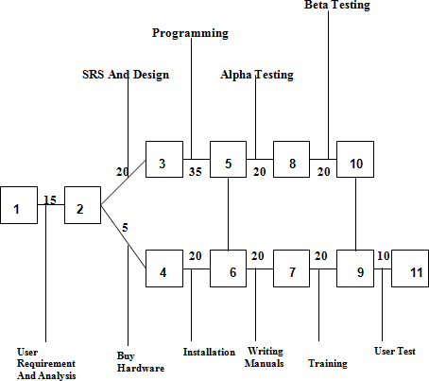

A PERT chart presents a graphic illustration of a project as a network diagram consisting of numbered nodes (either circles or rectangles) representing events, or milestones in the project linked.

The PERT chart is sometimes preferred over the [Gantt chart,](http://searchsoftwarequality.techtarget.com/definition/Gantt-chart) another popular project management charting method, because it clearly illustrates task dependencies. On the other hand, the PERT chart can be much more difficult to interpret, especially on complex projects. Frequently, project managers use both techniques.

## System Feature:

### Description and Priority:

The product offers the following Key features:

* Web based Application
* Client-server architecture
* Supports for both intranet and internet operations
* Highly scalable and extendible

# Functional Requirements:

### General Constraints:

There are some of the general constraints that is pre-conditions, post-conditions and business rules which we need to maintain in our system they are listed below

##### Pre-Conditions

* First Respondent must register Client Survey panel.
* Getting survey on the basic of Target.
* Must check the closing date of the survey.
* Check the survey basic on which topic or field like (Candy, Electronics, Cloths, etc.).
* Check Rewards points of that survey.

### Post-Conditions

* Survey must be submitted successfully.
* Rewards point are credit in account after the data verified.
* Once the Survey Link used cannot be used again for taking survey again.

### Business Rules

* NSMX Team remove all the wage responses after the client confirmation.
* Rewards Points are credit in the account after the successfully data verified.
* The respondent should be satisfied and cannot bounded.

# External Interface Requirements:

### User Interface:

The user interface is an important part of this software and will make the software very user friendly.

* **Input Screen:** The input screen should have some icons that will be used for opening the browse window and importing the input files. It should also show the files that are being imported. This screen should also have a time line over which the imported files can be placed and the duration of the files in the presentation can be adjusted.
* **Preview Screen:** The preview screen should be able to show the presentation slides, video and the table of contents as a complete multimedia presentation.
* **Publish Screen:** The publish screen must get the input from the user about where to store the presentation. It should show some animation representing the status of the publishing wizard.

# Hardware Interface:

It is recommended that the minimum configuration for clients is as appended below:-

* + - Processor : Pentium Series (1GHz or above)
    - RAM : 1GB
    - Hard Disk : With 80GB or above
    - Monitor : SVGA Monitor
    - Keyboard : Normal/Multimedia
    - Mouse : Stranded

# Software Interface:

* + - Frontend : Python, JavaScript, XML,JQuery
    - Back end : MYSQL
    - Tools : Java Script,CSS Client provided tool
    - Languages : Python
    - Operating System : Windows, and &Above

# Communication Interface:

* Client on Internet will be using HTTP and HTTP protocol.
* Client on Intranet will be using TCP/IP protocol.
* A Web Browser such as IE 5.0 or equivalent.

# Non-Functional Requirements:

### Performance Requirements:

To achieve good performance the following requirements must be satisfied

* + - ***Scalability*:** The ease with which a system or component can be modified to fit the problem area.
    - ***Portability:*** The ease with which a system or component can be transferred from one hardware or software environment to another.
    - ***Security:*** It is the ideal state where all information can be communicated across the internet/company secure from unauthorized persons being able to read it and/or manipulate it. It is also the process of preventing and detecting unauthorized use of one’s computer.
    - ***Maintainability:*** The ease with which a software system or component can be modified to correct faults, improve performance, or other attributes, or adapt to a changed environment.
    - ***Reliability:*** The ability of a system or component to perform its required functions under stated conditions for a specified period of time.
    - ***Reusability:*** The degree to which a software module or other work product can be used in more than one computing program or software system.

# Safety Requirements:

Database is an important aspect of any system. So it is required to take backup of the database. Special exception handling mechanism should be in place to avoid system error.

In case scenarios where data integrity can be compromised, measures should be taken to ensure that all changes are made before system is shutdown. The user must have a registered account to use all facility of the web application

# Security Requirements:

* + - * Only Specific Country / Region can take the survey those are targeted by the client.
      * Respondent cannot view the report and respondent data.

## Software Quality Attribute:

1. **Functionality:** The capability to provide functions which meet stated and implied needs when the software is used.
2. **Reliability:** The capability to maintain a specified level of performance.
3. **Usability:** The capability to be understood, learned and used.
4. **Efficiency**: The capability to provide appropriate performance relative to the amount of resources used.
5. **Maintainability:** The capability to modify for the purpose of making corrections and improvement.
6. **Portability:** The capability to adopt for different specified environments without applying actions or means other than those provided for this purpose in the product.

## Other Requirements:

### Appendix A: Glossary:

* + **HTML:** Hypertext markup Language is markup language used to design static webpages.
  + **MySQL:** MySQL Database is the database management system that delivers a flexible and cost effective database platform to build robust on demand business applications.
  + **HTTP:**Hypertext Transfer Protocol is a transaction oriented client/server protocol between web browser & a Web Server.
  + **HTTPS:** Secure Hypertext Transfer Protocol is a HTTP over SSL (secure socket layer)
  + **TCP/IP:** Transmission Control Protocol/Internet Protocol, the suite of communication protocols used to connect hosts on the Internet. TCP/IP uses several protocols, the two main ones being TCP and IP.
  + **XML:** Extensible Markup Language (XML) is used to describe data. The XML standard is a flexible way to create information formats and electronically share structured data via the public Internet, as well as via corporate networks.
  + **Python:** Python is an interpreted, object-oriented, high-level programming language with dynamic semantics. Its high-level built in data structures, combined with dynamic typing and dynamic binding, make it very attractive for Rapid Application Development, as well as for use as a scripting or glue language to connect existing components together.

# Appendix B: Analysis Model:

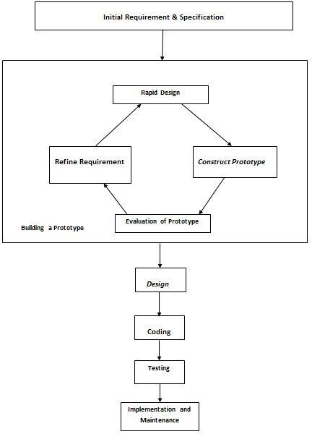

## 8. Software Engineering Paradigm Applied

Software engineering is a layered technology. The foundation for software engineering is the process layer. Software engineering processes the glue that holds the technology layers together and enables ratios and timely development of computer software. Process defines a framework for a set of key process areas that must be established for effective delivery of software engineering technology.

Software engineering methods provide the technical how-to’s for building software. Methods encompass a broad array of tasks that include requirements analysis, design, program construction, testing and support. Software engineering tools provide automated or semi-automated support for the process and the methods. When tools are integrated so that information created by one tool can be used by another tool, a system for the support of software development, called computer-aided software engineering is established.

#### The following paradigms are available:

* 1. The Waterfall Model
  2. The Prototyping Model

# The Prototyping Model:

The Prototyping model is similar to the waterfall model with some differences. It has been noticed by several system analysts that most of the time, the customer is not sure about the functionality he requires in the software product. In such cases, it is not considered a good practice to develop a product as only perceived by the software development team. Before preparing the SRS documents, the customers must also understand the functionality of the product. Under such circumstances, the prototyping model for software development is used. In this approach a quick design of the product is prepared and shown to the customer. Prototype is a toy representation of the software modified. As per the suggestion of the customer, the prototype is rebuilt and modified. Once the customer accepts the design, the design phase according to the waterfall model starts.



**Testing**

**Implementation and**

**Maintenance**



**InitialRequirement&Specification**

***Design***

**Coding**

**Evaluation of Prototype**

**Building a Prototype**

***Construct Prototype***

**Refine**

**Requirement**

**RapidDesign**

Fig: The Prototype Model

# The Project is based on Prototype Model as:

A throw away prototype is built to help understand the requirements. This prototype is developed based on the prototype obviously under goes design, coding & testing, but each of these phases is not done very formally or thoroughly. By using this prototype the client can get an actual feel of the system, because the interactions with the prototype can enable the client to better understand the requirement of the desired system.

Design Code Test

In this Project used **Prototype Model** because the system is complicated and large and there is no existing system (computerized) prototyping is an attractive idea. In this situation letting the client test the prototype provides the variable inputs, which help in determining the requirements of the system. It is also an effective method of demonstrating the feasibility of a certain approach.

### Some Advantages of Prototype model:

* + - Reduces development time.
    - Reduces development costs.
    - Requires user involvement.
    - Developers receive quantifiable user feedback.
    - Facilitates system implementation since users knows what to expect.
    - Results in higher user satisfaction.
    - Exposes developers to potential future system enhancements.

**9. High Level Design**

### Data Flow Diagrams:

* ***Context/Zero Level DFD:***

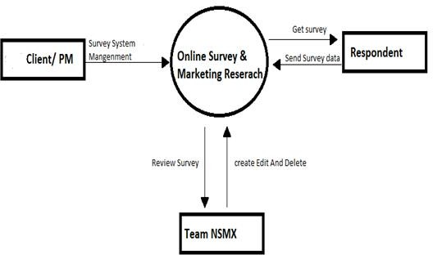

* ***1- Level DFD:***

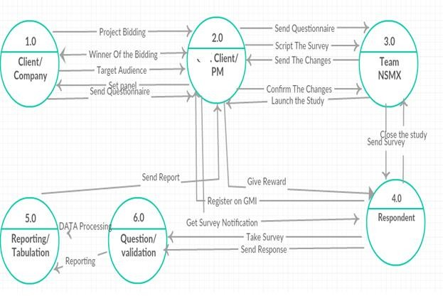

1. ***ER-Diagram:***

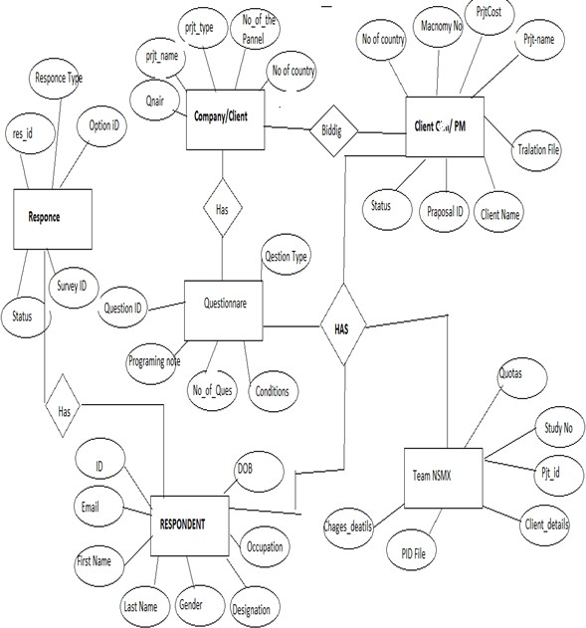

1. ***Use Case Diagrams:***

Use Case Diagram For Client:

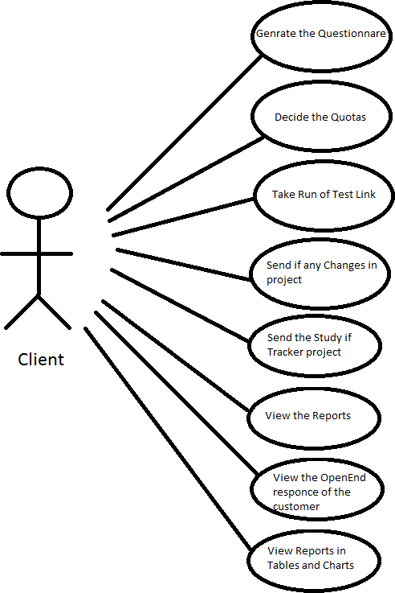

Use Case Diagram For Client And Team NSMX:

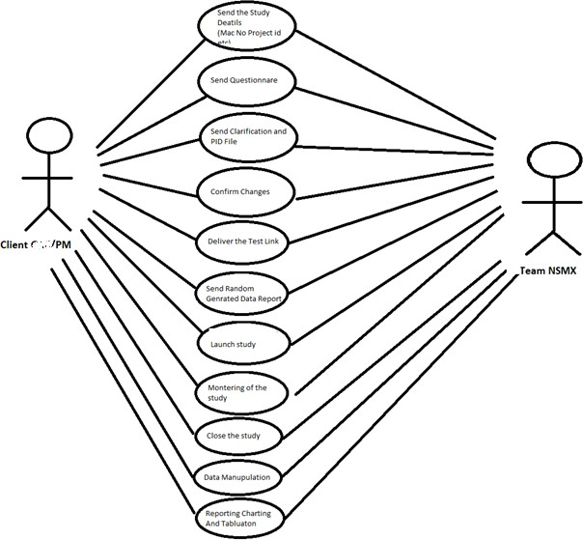

## 10. Database Design

**Database Name: *Auto taken System***

#### Table Structure:

* + Project Details
  + Client Details
  + Project Adding in PM Tool
  + Heads Up Request Table
  + Initial Testing Request
  + Client Delivery Details
  + Survey Data and Global Variable Capture:
  + Quota Tables:
  + Drop-Out Table:
  + Terminates Table:
  + Completion Table:
  + Final Respondent data Reports:

#### Table: Project Adding in PM Tool:

|  |  |  |  |
| --- | --- | --- | --- |
| **Column Name** | **Length** | **Data type** | **Constraints** |
| **Project Name** | 100 | Varchar |  |
| **Proposal ID** | 30 | Number | Unique |
| **PM - Tool Study Number** | 6 | Number | Primary Key |
| **Maconomy Job Number** | 10 | Number | Unique |
| **Client Company Name** | 50 | Varchar |  |
| **Account Manager** | 50 | Varchar |  |
| **Primary Project Manager** | 50 | Varchar |  |
| **Secondary Project**  **Manager** | 50 | Varchar |  |
| **Project Specifications (Adhoc or**  **Tracker)** | 10 | Varchar |  |
| **Number of Countries (for Adhoc)** | 5 | Integer |  |
| **Country Names** | 50 | Varchar |  |

**Table: Heads up Request Table:**

|  |  |  |  |
| --- | --- | --- | --- |
| **Column Name** | **Length** | **Data type** | **Constraints** |
| **Date** | 20 | DATE |  |
| **Request Type** | 30 | Varchar | Not null |
| **Project ID** | 45 | NUMBER | Not null |
| **Project Name** | 45 | Varchar | Not null |
| **Main Programmer Name** | 20 | Varchar | Not null |
| **Request Time** | 45 | Varchar | Not null |
| **Link Delivery Time** | 45 | Varchar | Not null |
| **Complexity** | 10 | Varchar | Not null |
| **Questionnaire**  **Attached (Y/N)** | 45 | Varchar | Not null |

**Table: Initial Testing Request**

|  |  |  |  |
| --- | --- | --- | --- |
| **Column Name** | **Length** | **Data type** | **Constraints** |
| Project PM - Tool  Number #: | 10 | NUMBER | Primary key |
| Project Name #: | 100 | Varchar |  |
| Client: | 50 | Varchar |  |
| Project Type : | 50 | Varchar |  |
| (*New, Modifications, Wave, Changes,*  *Tracker, con-joint*) | 50 | Varchar |  |
| Total Questions: | 10 | Integer |  |
| Survey Urls : | 500 | Varchar |  |
| Complexity: *(1/2/3)* | 1 | Integer |  |
| Stimulated Data:  *(Yes/No)* | 10 | Varchar |  |
| Quota: *(Yes/No)* | 10 | Varchar |  |
| Media Files  *(Yes/No)* | 10 | Varchar |  |
| Feedback Expected | 300 | Varchar |  |

**Table: Client Delivery Details:**

|  |  |  |  |
| --- | --- | --- | --- |
| **Column Name** | **Length** | **Data type** | **Constraints** |
| Project PM - Tool  Number #: | 10 | NUMBER | Primary key |
| Delivery Date | 50 | DATE | NOT NULL |
| Delivery Time: | 50 | Varchar | NOT NULL |
| Client Checklist (If  any) : |  |  |  |

**Table: Survey Data and Global Variable Capture:**

|  |  |  |  |
| --- | --- | --- | --- |
| **Column Name** | **Length** | **Data type** | **Constraints** |
| Access Code | 30 | Varchar | Primary Key |
| Panelist | 30 | Varchar | Unique |
| Age | 5 | Integer |  |
| Gender | 5 | varchar |  |
| Source | 10 | varchar | Unique |

**Table: Quota Tables:**

|  |  |  |  |
| --- | --- | --- | --- |
| **Column Name** | **Length** | **Data type** | **Constraints** |
| Quota Name | 50 | Varchar | Not Null |
| Limit | 50 | Number | Not null |
| Total | 50 | Number | Not null |
| Need | 50 | Number | Not Null |

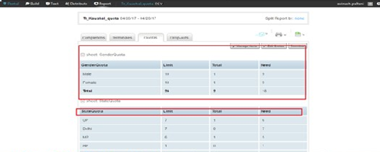

**Table: Drop-Out Table:**

|  |  |  |  |
| --- | --- | --- | --- |
| **Column Name** | **Length** | **Data type** | **Constraints** |
| Page | 10 | Number | Unique |
| Question | 200 | Varchar | Not Null |
| Completed (%) | 50 | Varchar | Not Null |
| Time | 20 | Time | Not Null |





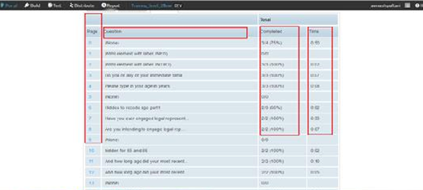

**Table: Terminates Table:**

|  |  |  |  |
| --- | --- | --- | --- |
| **Column Name** | **Length** | **Data type** | **Constraints** |
| Non-qualified: CrossQuota | 20 | Number | Not Null |
| Overquota | 20 | Number | Not Null |
| Dupe (cookie/ID) | 20 | Number | Not Null |
| Age term | 10 | Number | Not Null |
| S4 |  | Number | Not Null |
| S5 And S6 | 10 | Number | Not Null |
| S7A |  | Number | Not Null |
| Total Terminates | 10 | Number | Not Null |
|  |  |  |  |

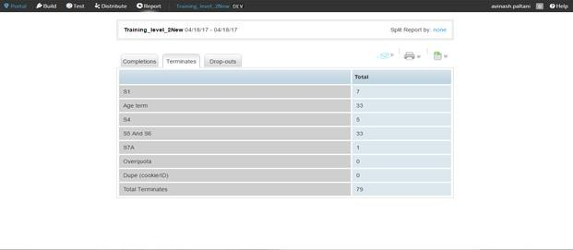

**Table: Completion Table:**

|  |  |  |  |
| --- | --- | --- | --- |
| **Column Name** | **Length** | **Data type** | **Constraints** |
| Click-Through | 20 | Number | Not Null |
| Partial Completes | 20 | Number | Not Null |
| Overquota | 20 | Number | Not Null |
| Qualified  Completes | 20 | Number | Not Null |
| Participation Rate | 20 | Number | Not Null |
| Incidence (with  Overquota) | 20 | Number | Not Null |
| Incidence (without  Overquota) | 20 | Number | Not Null |
| Completion Time  (average) | 20 | Number | Not Null |
| Completion Time  (median) | 20 | Number | Not Null |
| Total | 20 | Number | Not Null |
|  |  |  |  |

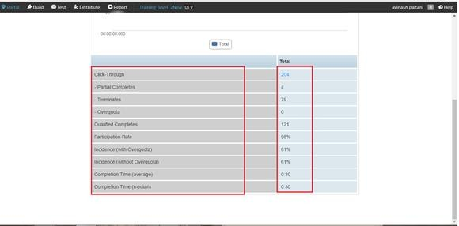

**Table: Final Respondent data Reports:**

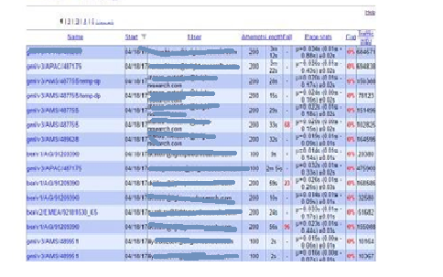

**Screen Shots**

***Login Page :***

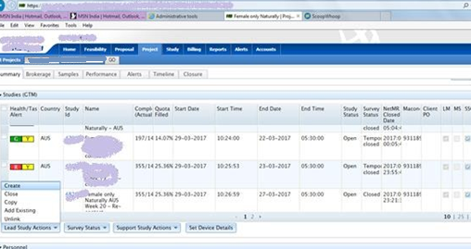

***After login Home Page:***

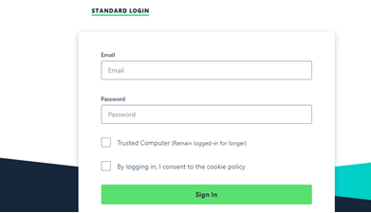

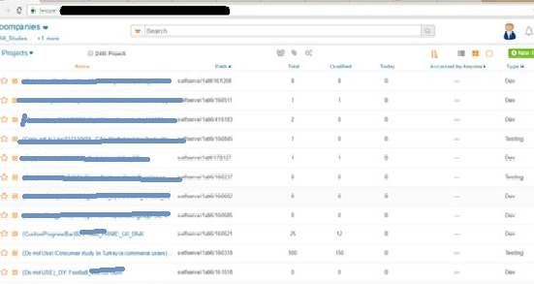

**Types of Set-Up in Questionnaire**

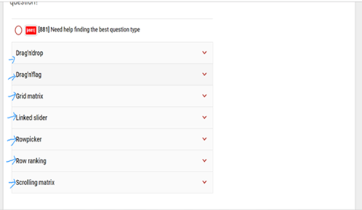

1. Row Picker

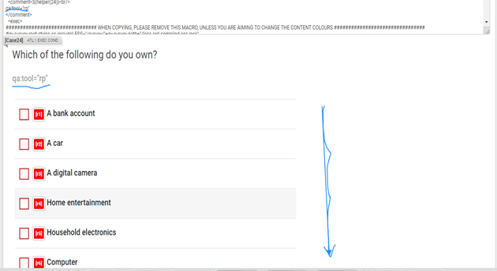

**2.) Drag and drop.**

***.***

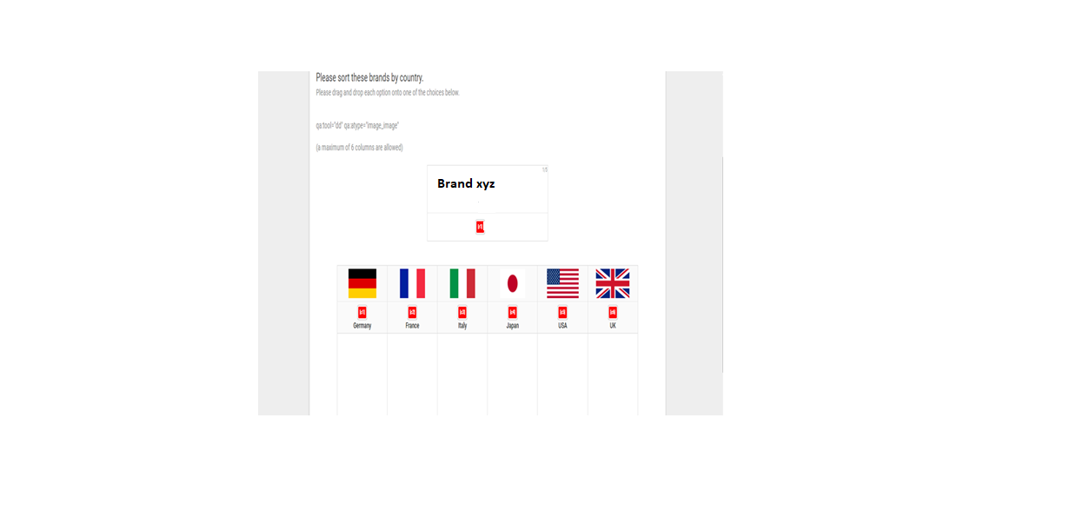

**3.) Grid Matrix**

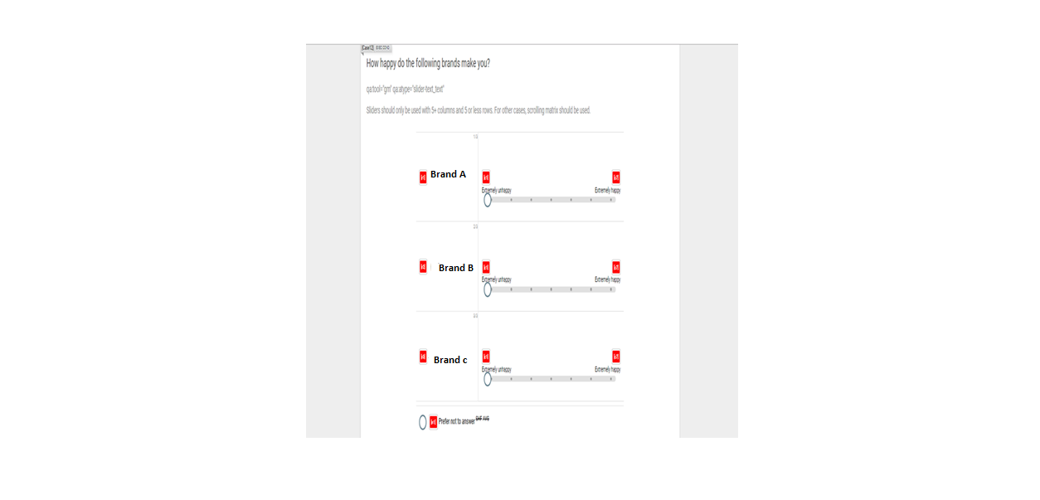

**4.) Drag and Flag**

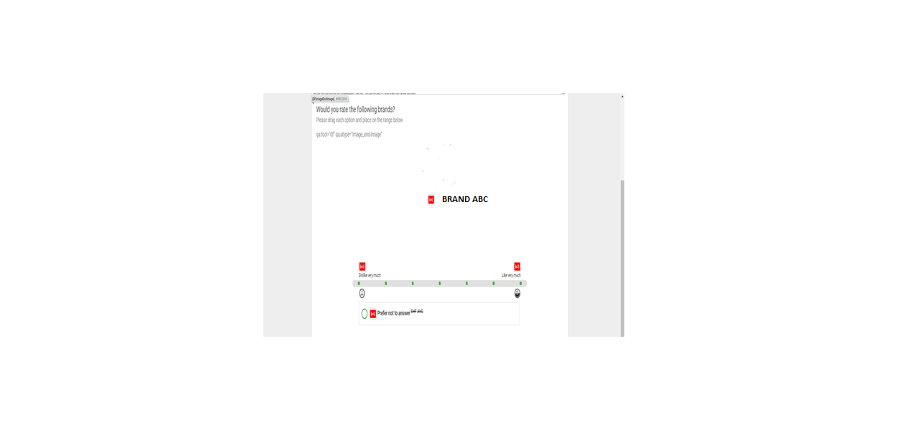

**5.) Link Slider**

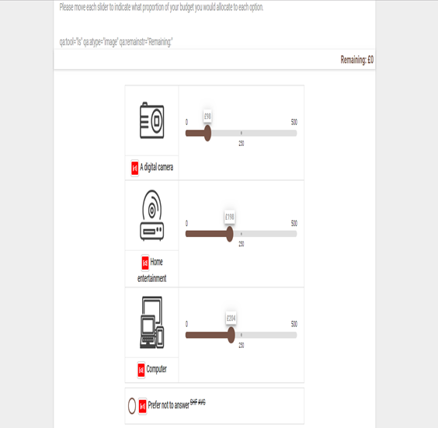

**6.) Scrolling Matrix.**

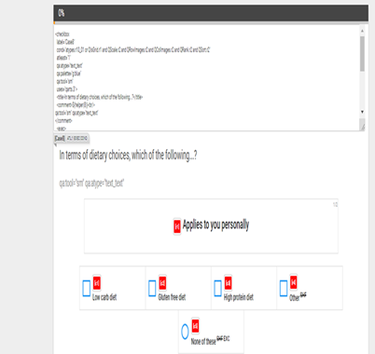

***Question Level Info:***

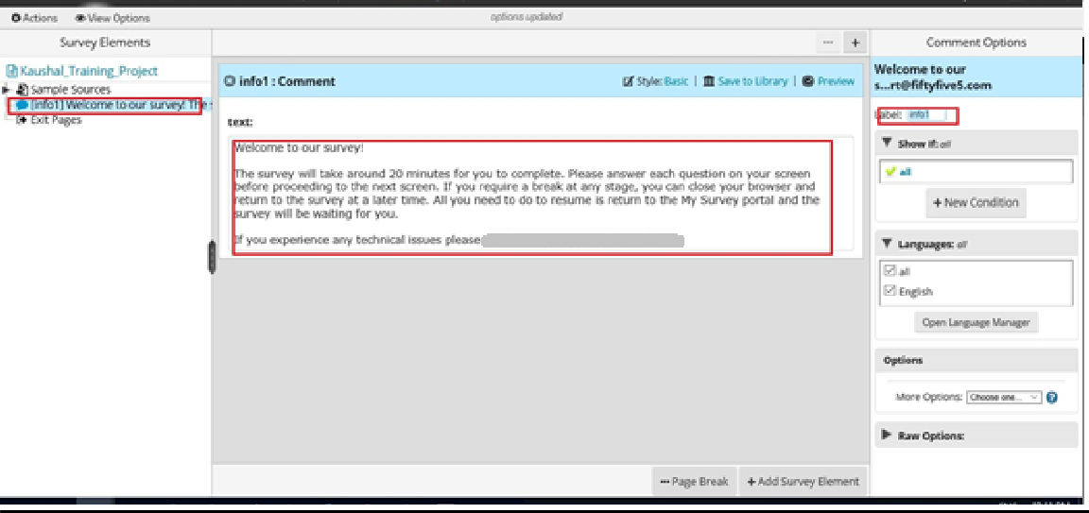

***Device Preview;***

1. ***Desktop Preview***

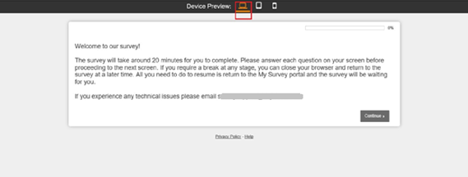

1. ***Tab Preview:***

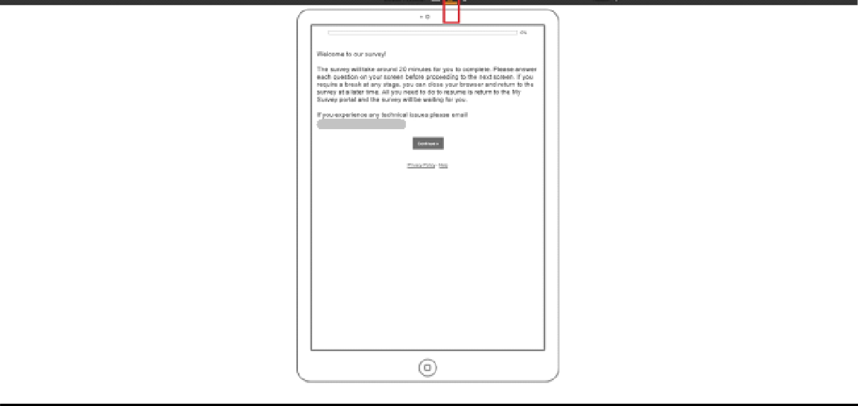

1. ***Mobile Preview:***

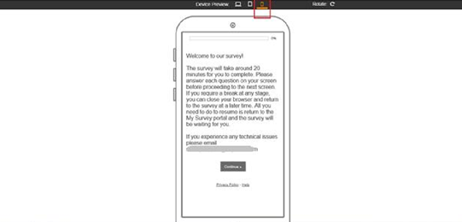

***Multi Select Question:***

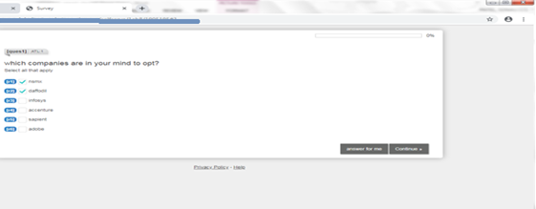

***Condition on Question:***

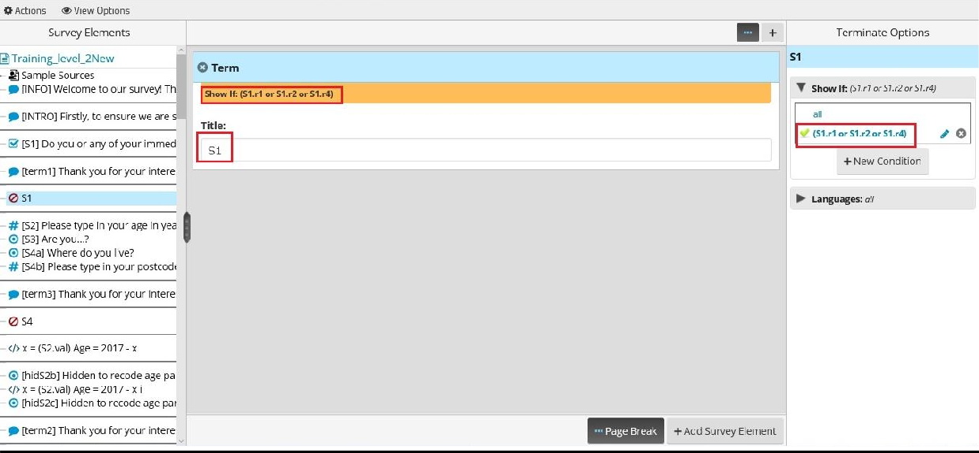

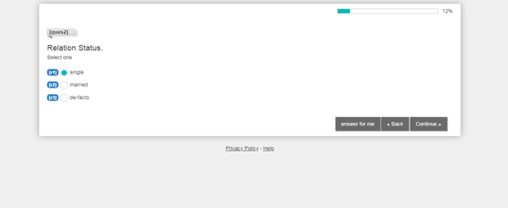

***Radio Select Question***

***Number Open End with Validation:***

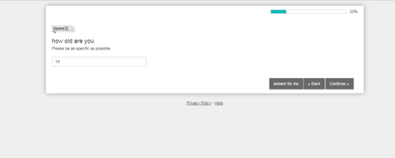

***Hidden Question For Respondent:***

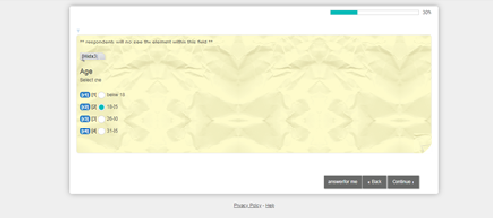

***Single Select Hidden Question:***

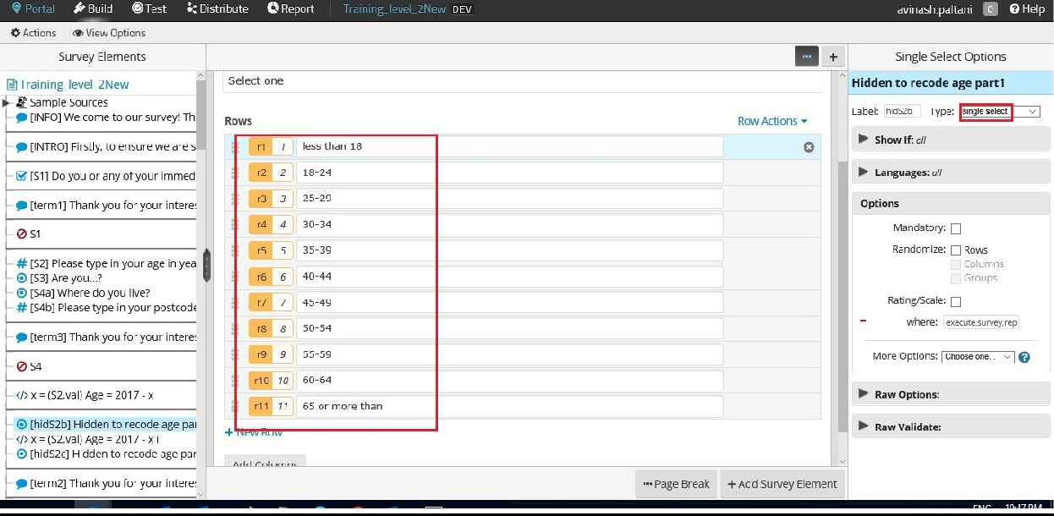

***Single Grid Hidden Question:***

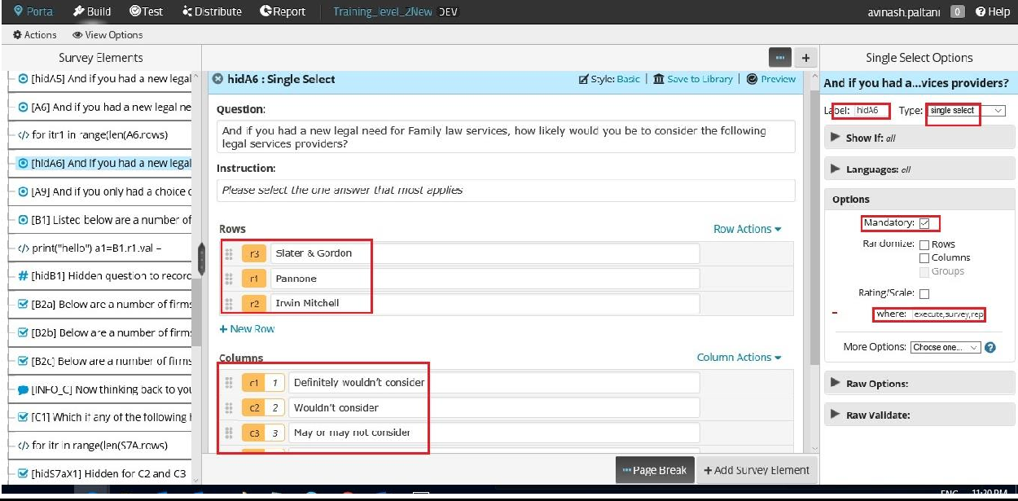

***Testing Environment:***

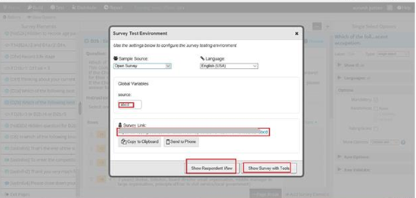

***Simple Info Question with Testing Tool:***

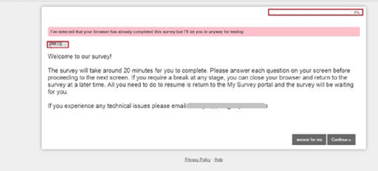

***Multiselect Question:***

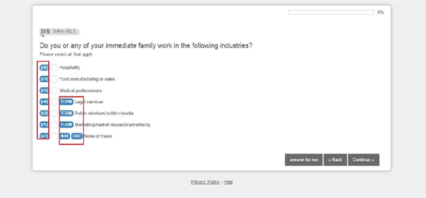

***Multiple Question on SamePage:***

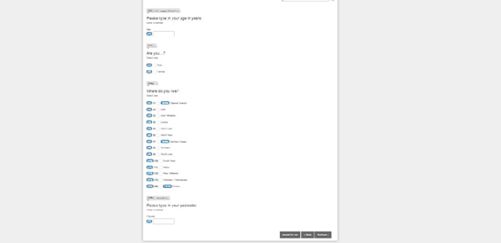

***Hidden Question Not visible to respondent:***

***Multiselect with Progress bar:***

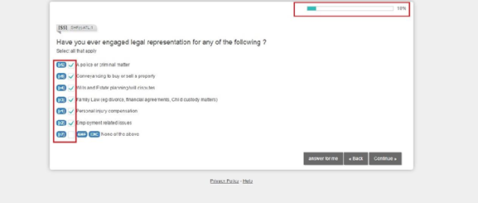

***Testing Tool With Value Recorder:***

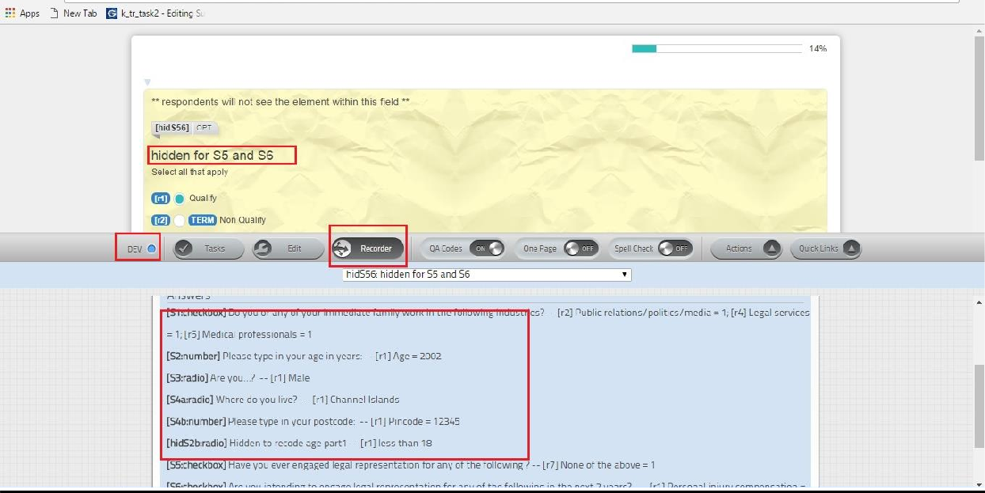

***Single Grid Question with Recorder:***

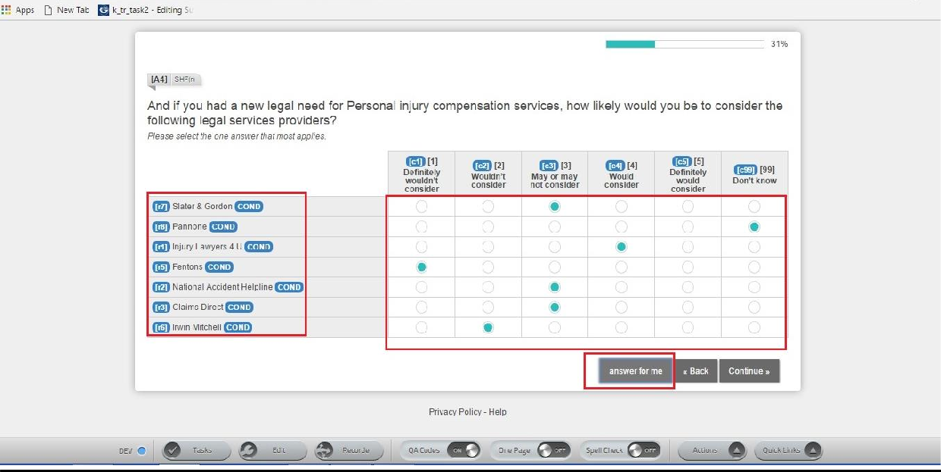

***Rating Question:***

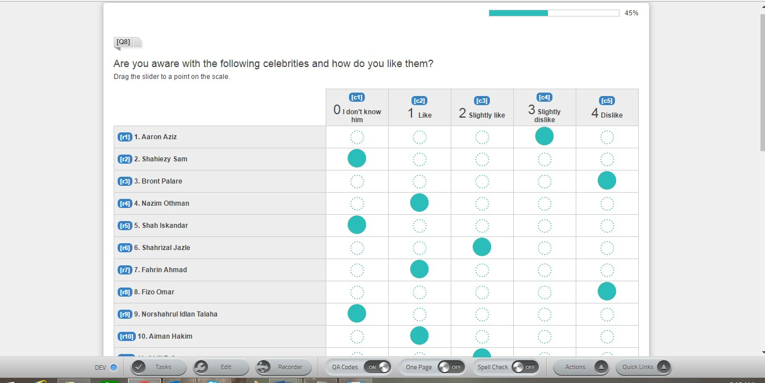

***Validation On the Text Box(with Incorrect data):***

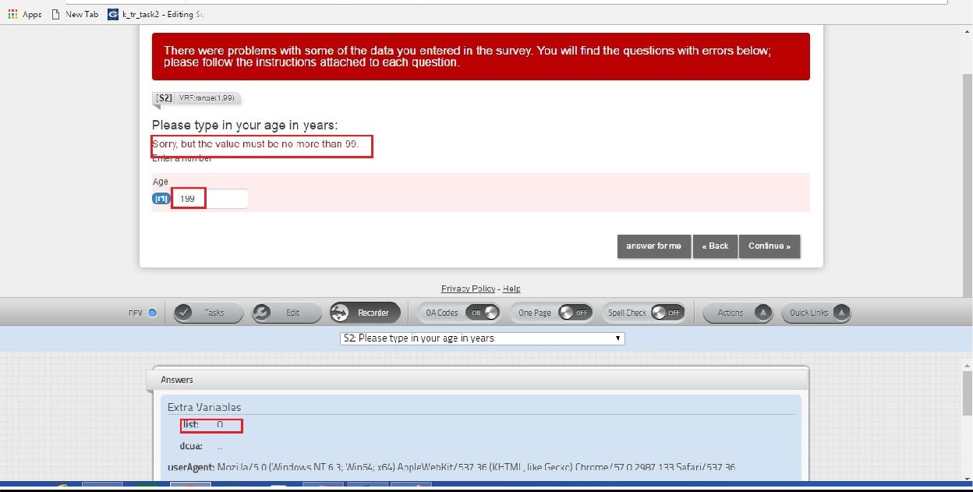

***With correct data :***

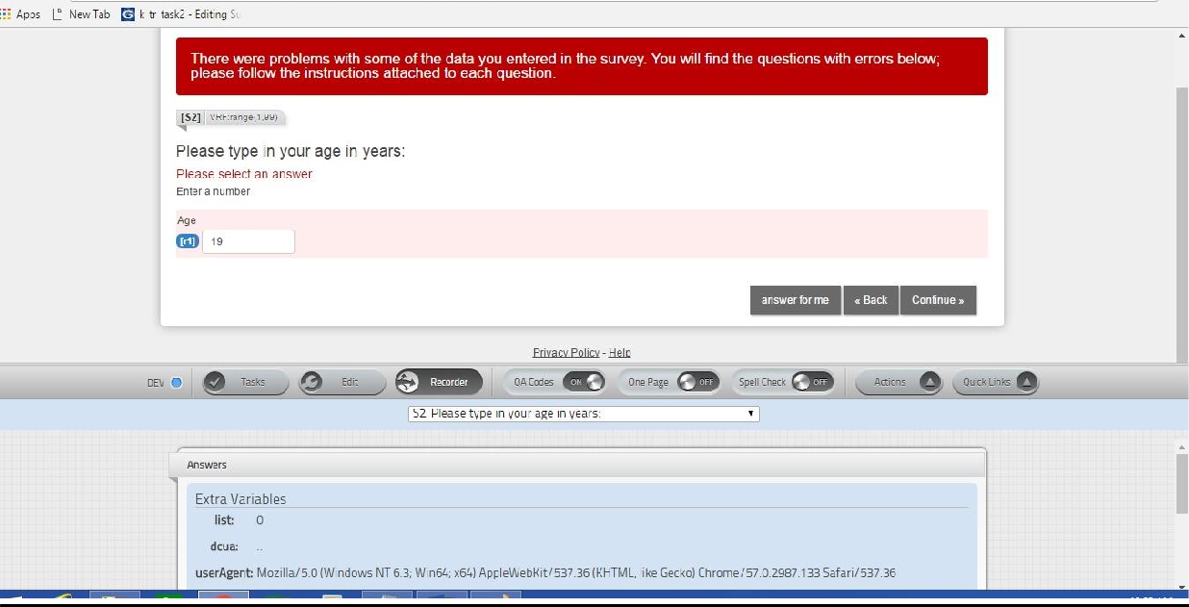

***Auto Punch on Hidden Question :***

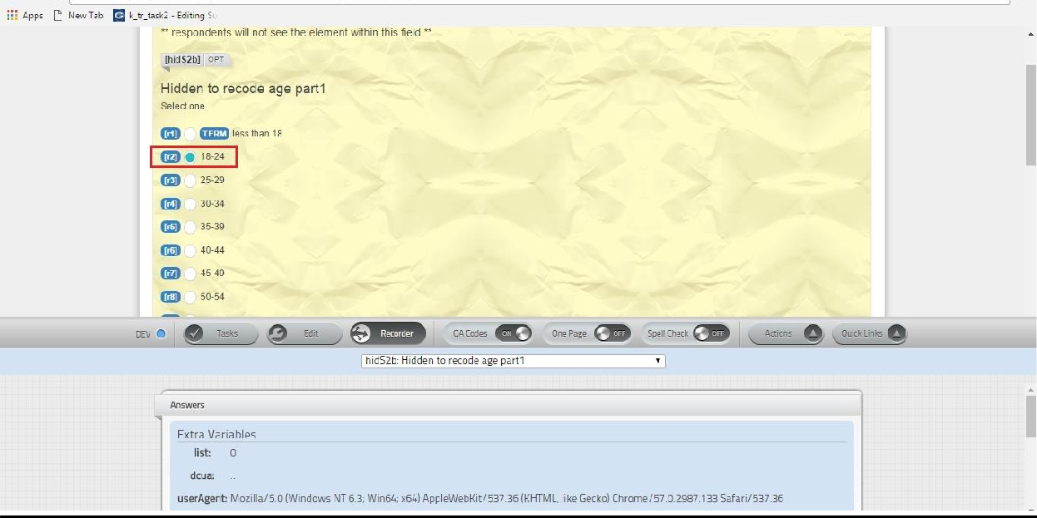

***Hover Text Question:***

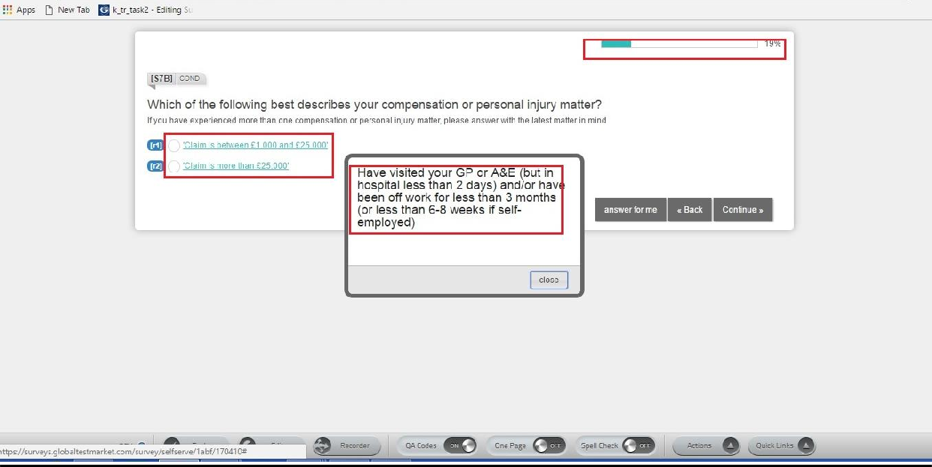

***Loop Question:***

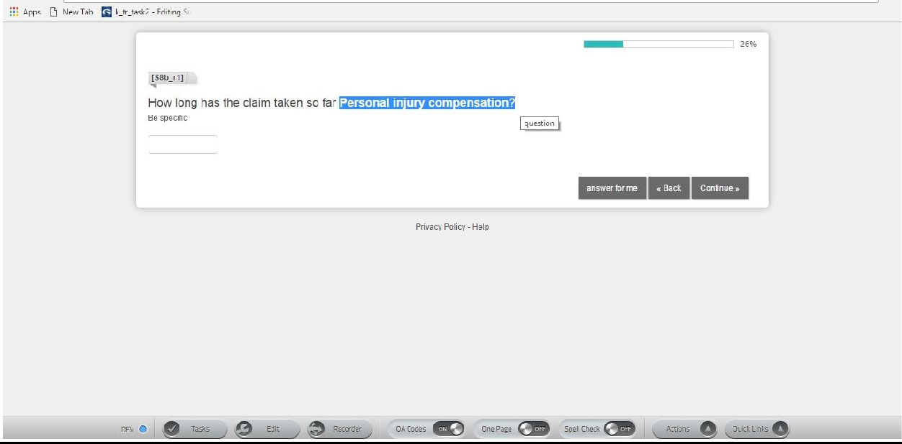

**Market Research-Quality Analysis & It’s Types**

* Basically in Market research-Quality Analysis we test and check whether online surveys are correctly implemented or not.
* In this, there are different methods of testing through which we test online surveys.
* Different Types of Testing are:-
  + **Manual Testing: -** There are three types of testing in it.
    - **Textual: -** In this, we check for textual errors that might be done by the programmer while preparing online survey.
    - **Logical: -** In this we logically check that correct implementation of logics has been there or not in the online survey. Some of the logics are Skipping, Piping, Masking, Randomization, Rotation, Terminates Exclusive and Cascading.
    - **Aesthetical:-** In this we aesthetically check whether survey is correct or not.
  + **Random Data Generation (RDG)** **:-** Respondent Data Testing by Random Data Generator.
  + **Q-Arts: -** It is a type of testing focusing more on look and feel of the Survey. In this testing there are sixteen KPI’s Guidelines which has to be followed while doing Q-Arts testing. Following are the
    - **KPI’S Guidelines :-**
* Intelligent Layout Usage
* Correct RI Instruction.
* Text Hierarchy
* Text conciseness.
* Placeholder’s Text
* Cap-Values.
* symmetry
* Display Don’t Know Option.
* Auto-Submit
* Question Usage
* Image Usage
* Scrolling
* Sizing
* Question Type Differention
* Scanning Patterns.

1. Other Types of testing are **Mobile and Browser Testing** in which we test on Different Browsers and mobile devices and Tabs to check whether survey is working fine or not.

|  |  |  |  |
| --- | --- | --- | --- |
| ***Test Cases:*** |  |  | |
| **Project History** |  |
| **Project ID** | 15122 |
| **Test Case History** |  |  |  |
| **Created By** | Atul singh | **Date Created By** | 01-04- 2021 |
| **Reviewed By** | Ayush Sachan | **Date Reviewed By** | 10-04-2021 |
| **Approved By** | **Amish Husain** | **Date Last Updated** | 15-04-2021 |
| **Test Executed By** | Atul singh |  |  |

#### Test Case Name: Logical Test_RUN

**Test Case Objective:** Logical Testing Of the Survey Study

|  |  |  |  |  |  |  |  |  |
| --- | --- | --- | --- | --- | --- | --- | --- | --- |
|  |  |  |  |  |  |  |  |  |
|  |  |  |  |  |  |  |  |  |
|  |  |  |  |  |  |  |  |  |
|  |  |  |  |  |  |  |  |  |
|  |  |  |  |  |  |  |  |  |
|  |  |  |  |  |  |  |  |  |

|  |  |  |  |  |  |  |  |  |  |  |  |
| --- | --- | --- | --- | --- | --- | --- | --- | --- | --- | --- | --- |
| **TC#** | **Test Design** | **Input Data** | **Expected Result** | | **Actual Result** | | **Pass** | **Fail** | **Comments** | | **Bug** |
| 1 | Enter the age | 12 | Terminate | | Terminated | | pass |  | Under age terminate | |  |
| 2 | Postal  code testing | 1234 | Error | | Error message | | Pass |  | Should 5 digit | be |  |
| 3 | Recode for age | 20 | 18-34 | | Punch 18-34 | on | Pass |  | Recode for age quota | |  |
| 4 | Answer Masking | 2  Option selected | Only answer show | 2 | Shown | | Pass |  | Answer Masking | |  |
| 5 | Answer Piping | 2  answer selected | selected answer go forward | | Piped | | Pass |  | Piping | |  |

|  |  |  |  |  |  |  |  |  |
| --- | --- | --- | --- | --- | --- | --- | --- | --- |
| 6 | Condition Testing | Select op 2 in S2 | Show only When @ selected in s2 | Working | Pass |  | Condition Checking |  |

1. **Test Case Name:** Textual testing

**Test Objective:** Should be same as the Client required for Quality.

|  |  |  |  |  |  |  |  |  |
| --- | --- | --- | --- | --- | --- | --- | --- | --- |
| **TC#** | **Test Design** | **Input Data** | **Expected Result** | **Actual Result** | **Pass** | **Fail** | **Comments** | **Bug** |
| TC_01 | Check the Question text with Questionnaire | Search the Exact text | Should be Same | Matched | Pass |  | Check the every question |  |

1. **Test Case Name:** Data Report Testing

**Test Case Objective:** All data are captured

|  |  |  |  |  |  |  |  |  |
| --- | --- | --- | --- | --- | --- | --- | --- | --- |
| **TC#** | **Test Design** | **Input Data** | **Expected Result** | **Actual Result** | **Pass** | **Fail** | **Comments** | **Bug** |
| TC_01 | Check the data download | Check details | No of variable Used | same as defined  in Script | Pass |  | should be same |  |

## Conclusion

Marketing Research is a growing and widely used business activity as the sellers need to know more about their final consumers but are generally widely separated from those consumers. Marketing Research is a necessary link between marketing decision makers and the markets in which they operate.

This type of research is used when there is some comprehension of the problem, objectives are defined and the research questions are clearly formulated. Contrary to exploratory research, the proof descriptive research provides is used for formulating action plans. It helps answer the questions ‘when’, ‘who’, ‘what’, ‘how’ and ‘where’, but not ‘why’.

Descriptive research typically gives a detailed account of the characteristics or behaviour of a population. Hence the research work usually involves some element of consumer profiling and market segmentation.

Marketing Research is essential for strategic market planning and decision making. It helps a firm in identifying what are the market opportunities and constraints, in developing and implementing market strategies, and in evaluating the effectiveness of marketing plans.

## 15. Future Scope

The Future Scope and Enhancement, which might be implemented in this proposed Project, can be-

* The System should be flexible enough so as to easily adapt to any future changes Likely to be added in the software.
* Should be supportive so as to hold large number of records in the database.
* Fuzzy goals lead to fuzzy results, and the last thing you want to end up with is a set of results that provide no real decision–enhancing value. Good surveys have focused objectives that are easily understood.
* Sounds obvious, but we have seen plenty of surveys where a few minutes of planning could have made the difference between receiving quality responses (responses that are useful as inputs to decisions) or un–interpretable data.
* Use of Secured Socket Layer (https) protocol to provide enhanced security for website.
* Short and focused helps with both quality and quantity of response. It is generally better to focus on a single objective than try to create a master survey that covers multiple objectives.

## 16. Bibliography

### Websites:

1. <https://www.surveymonkey.com/blog/2012/04/13/10-online-survey-tips/>
2. <http://www.managementstudyguide.com/limitations-marketing-research.html>
3. [http://www.vclcomponents.com/ASP_NET/Software/Free_Online_Survey_Softw](http://www.vclcomponents.com/ASP_NET/Software/Free_Online_Survey_Software-info.html)

[are-info.html](http://www.vclcomponents.com/ASP_NET/Software/Free_Online_Survey_Software-info.html)

1. [www.ieee.org](http://www.ieee.org/)
2. Google
3. [www.wikipidea.com](http://www.wikipidea.com/)